**MIDDLE EAST TECHNICAL UNIVERSITY**

**DEPARTMENT OF ELECTRICAL & ELECTRONICS ENGINEERING**



**TROY TECH**

**WEEKLY REPORT #4**

**06.03.2019-13.03.2019**

**Section :** 7

**Studio Coordinator:** Mustafa Mert ANKARALI

**Partners :**

Hasan ÖZKARA - 2031888

Kağan ÖZASLAN - 2031854

Caner POTUR - 2031250

Mustafa Ercan OKATAN - 2031193

Mert KAYIŞ – 2030997

**Progresses for Previous Week:**

* We have written and submitted ‘Critical Design Review Report’.
* We ordered an “Arduino Mega” to combine all the subsystems on our robot because we need more pins for subsystem interconnections on the final design. For instance, Arduino Uno was not enough for driving 3 DC motors and switching control of the solenoid.

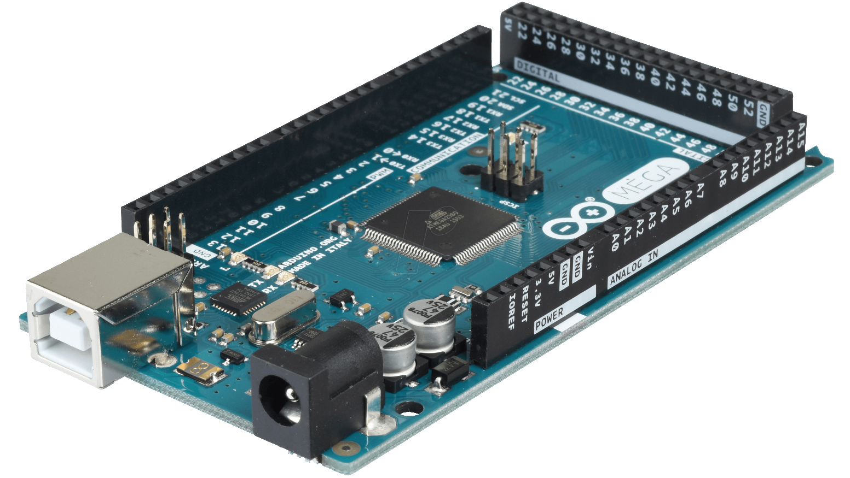

* We received some of the orders that we gave last week. We bought a solenoid whose size is considerably larger than the previous one.
* We did the subsystem level tests for the shooting system. We observed that the stroke of the new solenoid is powerful enough to shoot the ball which has a mass of 13 grams. We used 35V DC to test the solenoid because our step-up DC-DC converter supports output voltage up to 35V.

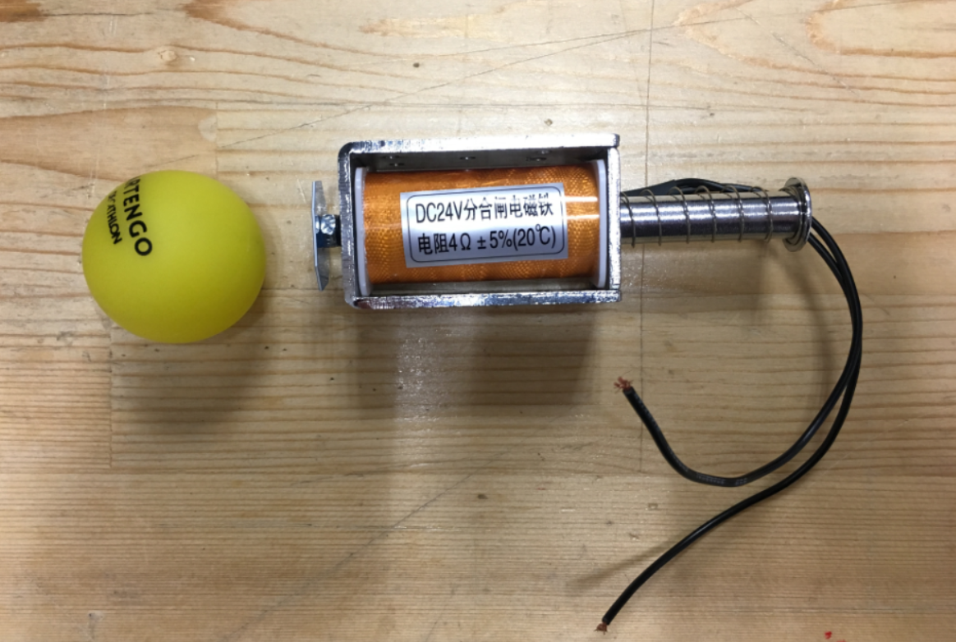

* We have discussed about our final design and shape of our robot.
* We bought a relay with the following specifications: 12V DC coil voltage and 15A current of operation.

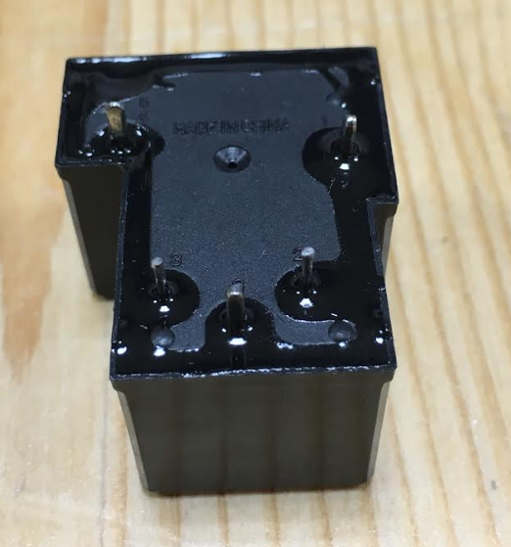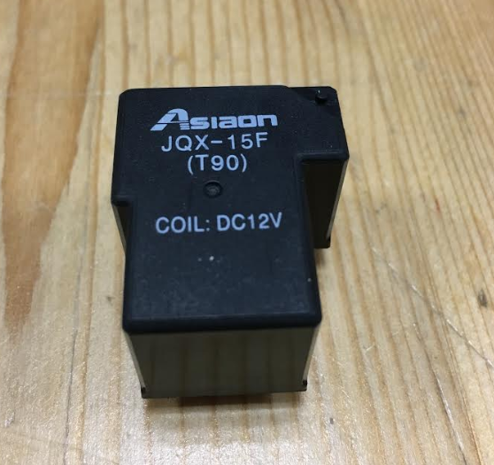

**Plans for the Next Week:**

* We will begin construction and installation of our design.
* We will draw detailed versions of final chassis of the robot.
* After determining the exact locations of cable paths, we will drill the plexiglass body.